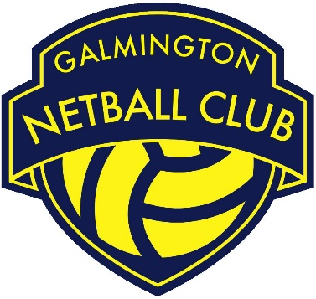

Role | First Aid Kit Manager
Committee Status | Non – Committee Role
Responsible to | Kit Manager
Working with | - Kit Manager, coaches and team captains to provide and re-stock first aid equipment
Roles & Responsibilities:

- Maintain an inventory of all first aid kits held by GNC.

- Order first aid kit as appropriate. Liaise with the Kit Manager, coaches and team captains regarding stock levels.

- Be the first point of contact for all first aid kit related queries.

- Carry out all roles and responsibilities in line with the GNC Privacy Policy and all other relevant policies and procedures.

- Be a positive role model for GNC club members/ volunteers by upholding the GNC Code of Conduct and acting as an ambassador of the club.

