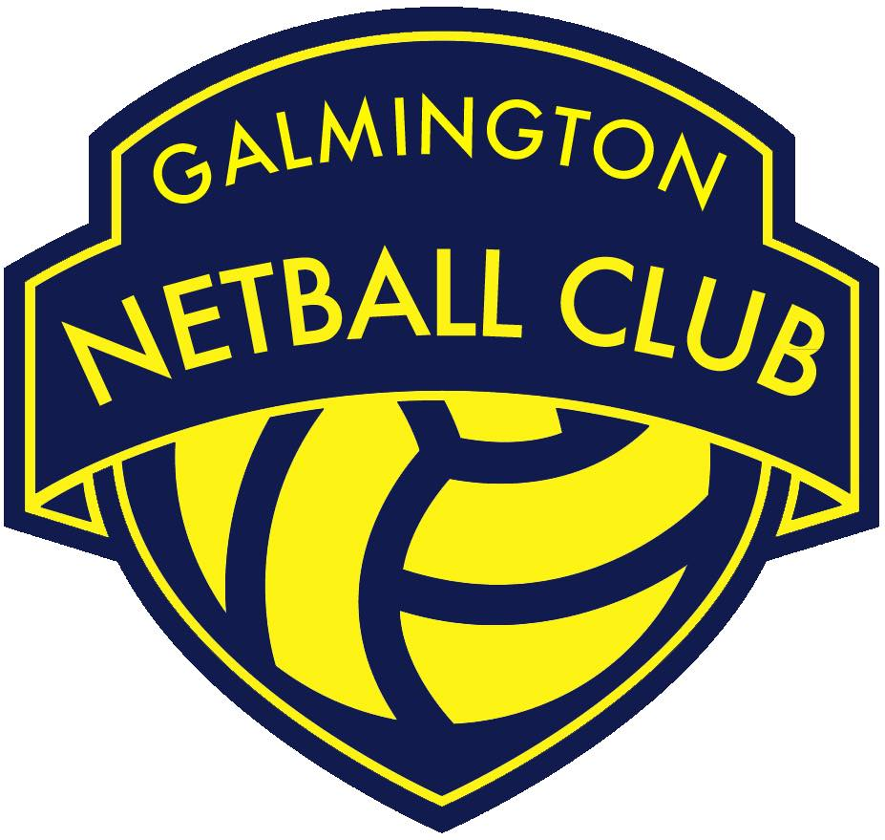

Role | Chair Person
Committee Status | Core Committee Member
Responsible to | The GNC Committee
Works with | - The GNC Vice Chair Person to discuss ideas and ask for feedback.  - The GNC Committee to support individuals in their roles and to contribute to sub group development plans with regard to the overarching GNC Development Plan.  - The GNC Safeguarding Officer to ensure that safeguarding standards are consistently met in the club.  - The GNC Lead Player Representative to decide whether a piece of feedback requires further action in line with the GNC Feedback and Complaints Policy.  - The GNC Treasurer to receive regular updates on GNC’s financial status.  - The GNC Secretary to coordinate meeting agendas, papers and any other communication to go to club members.  - All GNC club members, parents and volunteers to constantly get feedback and input in to the club.
Roles & Responsibilities:
- Support the efficient running of GNC.

- Attend 8 weekly GNC Committee meetings to include:
- Working with the GNC Secretary to create meeting agendas and papers
- Chairing the meetings
- Informing The GNC Committee on any updates from Somerset County Netball Association (SCNA), Netball South West (NSW), England Netball (EN) or any other relevant partner organisation

- Attend GNC’s Annual General Meeting to include:
- Working with the GNC Secretary to create the meeting agenda and papers
- Chairing the meeting
- Providing a whole club update/ round up report

- Help other GNC Committee members and club volunteers to understand their roles and responsibilities.

- Actively identifying new GNC Committee members and encouraging more volunteers to become involved.

- Lead on the development, implementation and monitoring of the GNC Development Plan including working with other GNC Committee members and volunteers to coordinate whole club feedback and input in to the plan.

- Lead on the development, implementation and monitoring of GNC’s Club Action Planning Scheme (CAPS) portfolio.

- Represent GNC at local, regional and national events such as The SCNA AGM and EN’s Goalden Globe Awards Ceremony.

- Assist the GNC Safeguarding Officer to ensure that GNC fulfils its responsibility to safeguard all club members in line with the GNC Safeguarding Policy.

- Work with the GNC’s Lead Player Representative to decide whether a piece of feedback requires further action in line with the GNC Feedback and Complaints Policy.

- Ensure an understanding of the legal responsibilities of the club such as GDPR and Safeguarding as well as the structure/s of all relevant Netball bodies relevant to GNC.

- Take responsibility for personal conflicts of interest and declaring, recording and managing these appropriately.

- Carry out all roles and responsibilities in line with the GNC Privacy Policy and all other relevant policies and procedures.

- Be a positive role model for GNC club members/ volunteers by upholding the GNC Code of Conduct and acting as an ambassador of the club.

