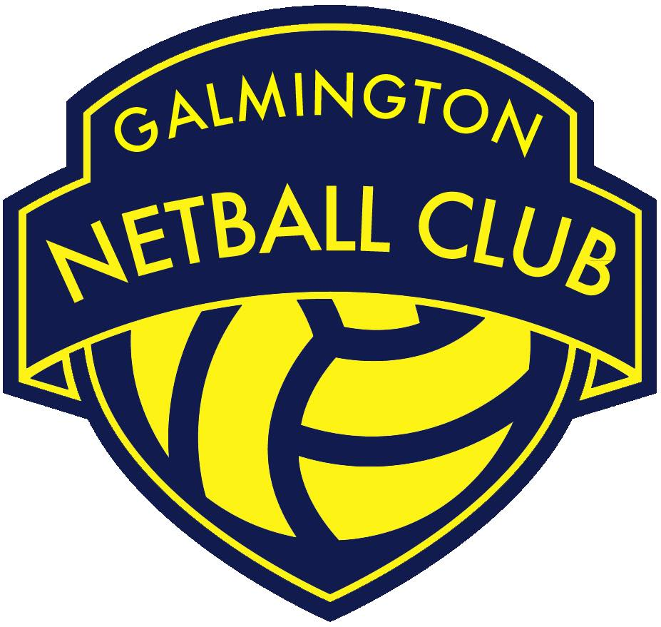

Role | Coaching Development Lead
Committee Status | Core GNC Committee Member
Responsible to | GNC Chair Person
Working with | - GNC Chair Person to align the GNC Coaching Development Plan to the overarching GNC Development Plan.  - GNC Treasurer to devise and report back on a budget for the GNC Coaching Development Plan.  - GNC Publicity Lead to communicate coaching courses/ workshops as necessary.  - GNC coaches to devise individual development plans.  - Other GNC Committee members and club members as necessary.
Roles & Responsibilities:
- Attend 8 weekly GNC Committee meetings and provide an update on the GNC Coaching Development Plan.

- Develop a SMART GNC Coaching Development Plan, which clearly outlines GNC’s commitment to developing and supporting coaches throughout all sections of the club.

- Work with the GNC Treasurer to agree a budget to support the GNC Coaching Development Plan and oversee this budget, reporting back to the GNC Treasurer every 8 weeks (in line with the GNC Committee meeting schedule).

- Stay abreast of any and all coaching courses/ workshops in the South West region and signpost club members accordingly.

- Keep an up to date register of coaching courses/workshops attended by GNC club members and volunteers.

- Keep an up to date register of all coaching qualifications obtained by GNC club members and volunteers.

- Identify and train potential coaching mentors within and outside of GNC.

- Establish an in house coaches mentor scheme.

- Work with GNC’s coaches to develop individual development plans.

- Carry out all roles and responsibilities in line with the GNC Privacy Policy and all other relevant policies and procedures.

- Be a positive role model for GNC club members/ volunteers by upholding the GNC Code of Conduct and acting as an ambassador of the club.

