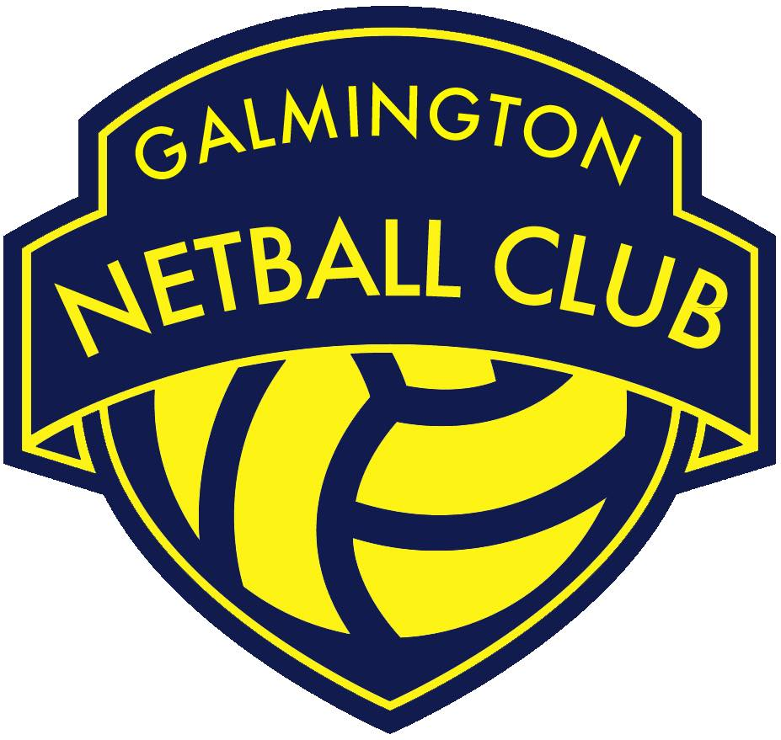
GNC Feedback and Complaints Policy

1. Our commitment
2. Definition
3. General principles
4. How to complain
5. Dealing with complaints and comments
6. Training for club members, volunteers and committee members
7. Collating data from comments and complaints
8. Audit and review
9. Related documents
Appendix A- Complaints and feedback form

1. OUR COMMITMENT
1.1 Galmington Netball Club (GNC) will take seriously, all feedback and complaints received from club members, volunteers, members of the public and any other stakeholder.
1.2 All complaints will be dealt with in accordance with the procedure outlined at section 5 of this policy. Where the complainant does not wish to provide their contact details, the complaint will still be processed in accordance with section 5, where there is enough evidence available to substantiate the complaint.
1.3 GNC is committed to providing a positive netball experience and continually strives to meet expectations. From time to time things can go wrong or are perceived by others to have gone wrong. When this happens we will:
● Treat the complaint and the complainant with respect and dignity and deal
with them fairly and sympathetically;
● Deal with the complaint swiftly, thoroughly, impartially and confidentially;
● Adopt a positive approach by using the complaint as an opportunity to take
actions to improve GNC, and;
● Provide an effective response and ensure, where appropriate, the cause of
the complaint is addressed.
1.4 Any club member or volunteer may receive feedback (including compliments). Any feedback should be forwarded on to The GNC Players Forum. It is the responsibility of The GNC Players Forum to decide if a piece of feedback or a complaint requires any further action. This may include a written response and informing the volunteer or club member who it concerns. The Chairperson will also be informed.
2. DEFINITION
2.1 This policy is intended to contribute to the effective and efficient operation of GNC, by providing a means of receiving feedback, compliments and complaints from club members, volunteers, members of the public and any other stakeholder.
2.2 A compliment is a positive remark about GNC or an individual.
2.3 Feedback is a suggestion or observation regarding GNC or a gap in the service it provides.

2.4 A complaint is an expression of dissatisfaction about the actions, decisions or apparent failings in GNC or an individual/ team within the club.

2.5 An investigation is a formal inquiry which may involve speaking with individuals concerned, taking statements and reviewing evidence.
3. GENERAL PRINCIPLES

3.1 This policy aims to:
3.2 Provide a consistent approach when dealing with feedback and complaints throughout GNC.
3.3 Provide a system whereby feedback and complaints can be dealt with promptly, fairly, politely and with understanding in all aspects of GNC.
3.4 Provide a confidential system that club members, volunteers, members of the public and any other stakeholder have confidence in.
3.5 Provide a standard, auditable and traceable process for GNC and users.
3.6 Encourage GNC members and volunteers to have a positive attitude towards feedback and complaints received.
3.7 Provide a means of collecting feedback or complaints about GNC, so that improvements can be made and where possible information regarding feedback and complaints can be published for the public to see.
3.8 GNC members and volunteers are representing the organisation during their involvement and every act will reflect upon the club, good or bad.
3.9 Every club member or volunteer should be prepared to receive feedback or complaints regarding the level of service or experience GNC is providing. The initial contact is important and will set the tone for how the individual feels they have been treated by the club.
4. HOW TO GIVE FEEDBACK AND MAKE A COMPLAINT
4.1 GNC deals with all users in a fair and equitable manner.

4.2 A variety of methods for offering feedback or making a complaint are available. These are as follows:

4.2.1 By sending an email to GNCplayersforum@gmail.com.

4.2.2 By using the feedback and complaints form which is attached to this policy or
available on the website.

4.2.3 By meeting with a member of The GNC Players Forum.
4.3 It is important for GNC members and volunteers to recognise the variety of contact methods available, as each person’s abilities and needs vary.
4.4 It is the responsibility of The GNC Players Forum to ensure that the matter is brought to the attention of the GNC Chairperson.
4.5 Unacceptable actions/aggressive behaviour- whilst fully supporting the right to complain, we expect our club members and volunteers to be treated courteously at all times. Violent or abusive language or behaviour towards them is unacceptable. Where there is a threat or use of physical violence or verbal abuse towards a club member or volunteer, all direct contact with the complainant will cease.
5. DEALING WITH FEEDBACK AND COMPLAINTS
FEEDBACK
5.1 Any GNC member or volunteer may receive feedback. This should be forwarded on to The GNC Players Forum to be actioned appropriately.
5.2 It is the responsibility of The GNC Players Forum in conjunction with the Chairperson to decide if a piece of feedback requires any further action. This may include a written response and informing the club member or volunteer who it concerns.
COMPLAINTS
5.3 Stage 1- Local Resolution
Most complaints can be dealt with informally and resolved quickly at the initial point of contact. The main principle is to seek early resolution, resolving complaints at the earliest opportunity. Any GNC member or volunteer can deal with a complaint at this stage.

5.4 Stage 2- Complaint investigated by the Lead Player Representative on The GNC Players Forum and nominated Committee Members
Where it has not been possible to achieve resolution under stage 1 or the complaint is more complex and requires detailed investigation, the complaint will be handled under stage 2 of the process. A stage 2 investigation aims to establish all the facts relevant to the points made in the complaint and to give the complainant a full, objective proportionate response.
5.5 Where a complaint is made and is to be dealt with under stage 2, a complaint form should be completed and sent to The GNC Players Forum by email or hand delivered. A complaint form is attached at appendix A.
5.6 The GNC Committee will put forward two committee members to deal with the complaint and investigation alongside the Lead Player Representative.

5.7 If the complaint involves a member of the GNC Players Forum or the GNC Committee that individual will not be involved in stage 2 of the process.
5.8 The following timescales apply under stage 2 of the complaint procedure:
● A formal acknowledgement of the complaint will be sent within 5 working
days.
● A full reply will be provided after an investigation within 30 working days.
● If a full response cannot be provided within the time set out above due to a
more complex investigation, an update will be provided with an expected
completion date.
5.9 If the complainant is dissatisfied with the response given under stage 2, they can
request a review of the complaint and investigation by The GNC Committee under
stage 3.

5.10 If the complaint involves a member of the GNC committee, that committee member will not be involved in stage 3 of the process.
5.11 Stage 3 – Complaint reviewed and investigated by the GNC Committee
● A formal acknowledgement of the review under stage 3 will be sent within 5
working days.
● A response will be provided after the review has been completed within 20
working days.
● If a full response cannot be provided within the time set out above due to a more complex review, an update will be provided with an expected completion date of the review under stage 3.
5.12 Where a complainant has exhausted the complaints procedure and continues to
dispute the outcome of their complaint, they will be advised that no further
discussion will take place on this issue, unless they can provide new information
relating to the complaint.

5.13 If appropriate to do so, all individuals involved in the complaint will be informed of the final decision.
6. TRAINING FOR CLUB MEMBERS, VOLUNTEERS AND COMMITTEE MEMBERS

6.1 For most club members and volunteers, training will include familiarisation and
understanding of the Feedback and Complaints Policy. Any club member or volunteer is able to seek clarification on matters relating to the Feedback and Complaints Policy by contacting the GNC Players Forum.

6.2 Where further training is required to effectively deal with feedback and complaints, this can be provided by the Committee through organised training events via England Netball.

6.3 Player Representatives and Committee Members who will be responsible
for conducting stage 2 investigations will require additional training. Appropriate
training will be identified and provided via England Netball.

7. COLLATING DATA FROM FEEDBACK AND COMPLAINTS
7.1 GNC keeps records of feedback and complaints made regarding the
service provided.
7.2 Upon conclusion of a complaint, those involved in investigating must forward to the
GNC Secretary all paperwork used and received during the complaint and any subsequent investigation. This information will be stored confidentially in accordance with Data Protection Laws, and the GNC privacy policy.

8. AUDIT AND REVIEW
8.1 The policy is designed to allow the use of feedback from our club members,
volunteers and other stakeholders with the aim of improving the netball experience
we provide.
8.2 The GNC Players Forum will review the information gathered from feedback
received and complaints and will consider whether areas of our club could be
improved.
8.3 This policy will be reviewed within a specified period as deemed appropriate by the
GNC Committee, but no longer than 2 years or when external influences occur such
as legislation.
8.4 Last review: April 2019
Next review: April 2021

9. RELATED DOCUMENTS
9.1 Feedback and complaints form (Appendix A).

