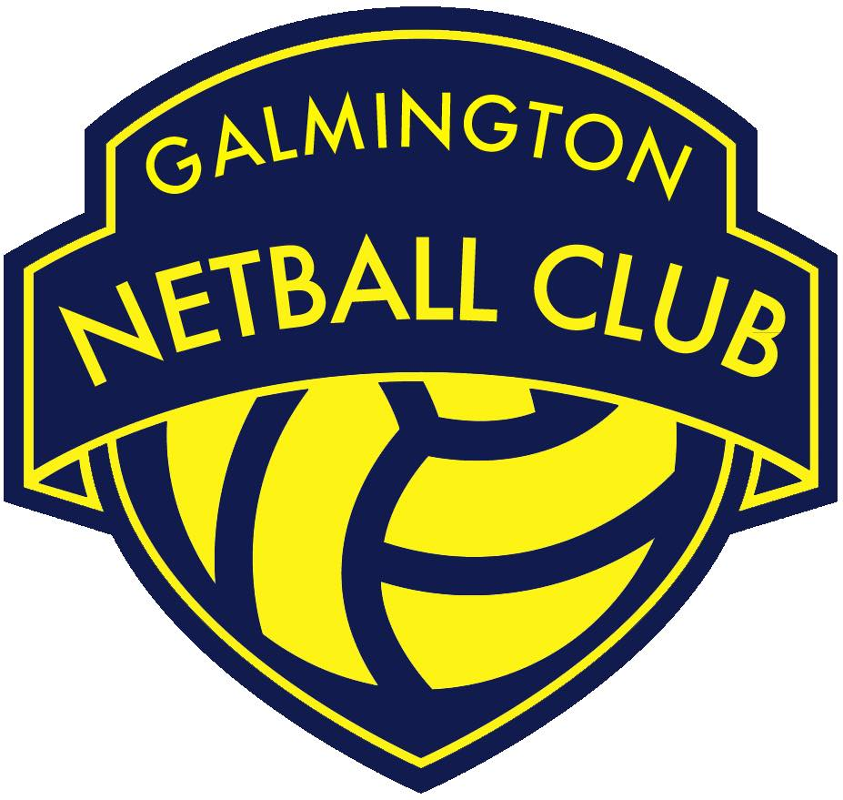

Role | Secretary
Committee Status | Core GNC Committee Member
Responsible to | GNC Chair Person
Work with | - GNC Chair Person to ensure the timely and accurate distribution and creation of correspondence and meeting papers.  - GNC Committee members to collate and compile meeting agendas and follow up progress on actions agreed.  - Other GNC Committee sub group volunteers and club members as necessary.
Roles & Responsibilities:
- Attend 8 weekly GNC Committee meetings and provide an admin function to include:
- Working with the GNC Chair Person to create meeting agendas
- Collating sub group committee reports and updates
- Circulating meeting papers
- Taking minutes of the meeting
- Setting up meeting events in the GNC Committee Facebook Group

- Attend GNC’s Annual General Meeting and provide an admin function to include:
- Circulating meeting papers
- Working with the GNC Chair Person to create meeting agendas
- Taking and distributing minutes of the meeting

- Monitor the GNC email inbox and respond to/ forward on enquiries.
- Send out communications to senior club members as agreed by the GNC Chair Person for example team announcements and club updates.

- Oversee progress made against a club wide timetable to ensure communications and activities such as court bookings are made in good time.

- Complete, return and file entry forms for senior leagues and tournaments.

- Distribute, collate and file accident forms.

- Seek out and collate nominations for club awards such as The Club Person of the Year Award and Karen Lewis Award.

- Ensure the standard formatting of all GNC policies and procedures and alert The GNC Committee when a policy or procedure is due for review.

- Support the GNC Chair Person on any admin pertaining to GNC’s Club Action Planning Scheme (CAPS) portfolio or GNC Development Plan.

- Coordinate gifts to be awarded at GNC’s end of season presentation evening.

- Carry out all roles and responsibilities in line with the GNC Privacy Policy and all other relevant policies and procedures.

- Be a positive role model for GNC club members/ volunteers by upholding the GNC Code of Conduct and acting as an ambassador of the club.

