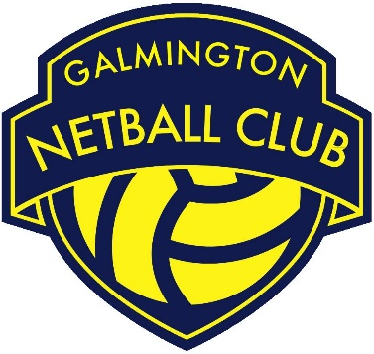

Role | Coach
Committee Status | Non – Committee Role
Responsible to | Lead Coach
Working with | - GNC Coaching Lead  - Lead Coach  - Players
Roles & Responsibilities:

- To assist the Lead Coach in the planning, organisation & delivery of weekly sessions to meet player & team needs.
- To undertake appropriate training including mandatory safeguarding training every 3 years.
- To undertake a DBS three yearly.

- To assist the Lead Coach in the selection of squads.
- To feed back to the GNC Coaching Lead to be fed into meetings of the GNC Committee 6 weekly.
- To work with other GNC Lead Coaches to identify & support club members feeding into Senior/ Regional League training & competition.
- To effectively communicate with players, club coaches and parents e.g. in relation to team selections & the introduction of new players at training.
- To find suitable cover for sessions/ matches that you are unable to attend.
- To work with the GNC Coaching Lead/ Lead Coach in being proactive in identifying opportunities for self-development.
- Carry out all roles and responsibilities in line with the GNC Privacy Policy, Health & Safety Policy, Equality Policy, Safeguarding Policy and all other relevant policies and procedures.

- Be a positive role model for GNC club members/ volunteers by upholding the GNC Code of Conduct and acting as an ambassador of the club.

