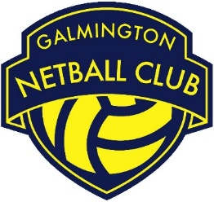

Role | Categories Administrator
Committee Status | Non – Committee Role
Responsible to | GNC Chair Person
Working with | - GNC Selectors  - GNC Coaches  - GNC Captains  - GNC club members  - GNC Chair Person
Roles & Responsibilities:

- Be the main point of contact for all category related queries.

- Responsible for reading and understanding the rules and regulations relating to all leagues that GNC are represented in.

- At the start of each season and throughout, work with selectors, coaches and captains to ensure that they fully understand the league requirements and category restrictions.

- Notify selectors, coaches, captains and individuals of any changes to their playing status throughout the season including changes of category.

- Work with selectors, coaches and captains to ensure all club members are aware of the basic requirements of playing in a team and the rules regarding which teams they can play in.

- Monitor the quarters played for each GNC player on a weekly basis, flag up any required actions with individuals, coaches, captains and selectors.

- Maintain adequate records of playing quarters and the category of each GNC club member. Share this information with coaches, selectors, captains and individuals as appropriate.

- Responsible for logging all squads with league officials within the given timeframe.

- Ensure that quarters played are submitted to league officials within the given timeframe.

- Update league officials of changes to squads and categories prior to match days via email

- Work to ensure that GNC do not incur fines for breaking league rules/regulations.

- Carry out all roles and responsibilities in line with the GNC Privacy Policy and all other relevant policies and procedures.

- Be a positive role model for GNC club members/ volunteers by upholding the GNC Code of Conduct and acting as an ambassador of the club.

